
Product Document
Vegetable Irrigation for Climate Resilience (VICT)

06th March 2025
Contents
1.0 OVERVIEW 4
2.0 SYSTEM ARCHITECTURE 5
2.1 User Interface 6
2.2 Admin Panel 7
3.0 TECHNOLOGY STACK 9
4.0 HOSTING 10
5.0 SYSTEM FEATURES 12
5.1 User Interface 12
5.1.1 Home 12
5.1.2 About 12
5.1.3 Decision Tool 13
5.1.4 Explore Technologies 13
5.1.5 Resource Center 14
5.1.6 Contact 15
5.2 Admin Panel 16
5.2.1 Login 16
5.2.2 Data summary 16
5.2.3 Data 17
5.2.4 Content 21
5.2.5 Admin 22

Revision History
Name | Date | Reasons of Changes | Version
i-Tech Mission | 03-Feb-2025 | The first draft of document developed. | V1
Project Details
Name | Vegetable Irrigation for Climate Resilience (VICT)
Country | Ethiopia and Mali
Agency
Partner Agency
Agency Focal Person
Agency Email
Development Team | i-Tech Mission

1.0 OVERVIEW
The Vegetable Irrigation for Climate Resilience (VICT) platform is developed as a web-based platform that uses a data-driven, evidence-based approach to support humanitarian agencies in designing and implementing irrigation investments for vegetable production. The platform comprises two applications: the User Interface and the Data Manager. The Data Manager application is accessed with valid login credentials, whereas the User Interface is accessed without a login.
During the process of development, various documents were developed, reviewed and submitted that included:
- Inception Report
- Software Requirement Specification (SRS)
- Knowledge Transfer and Capacity Building Plan
- User Guides
- Training Materials – Agenda, Training Presentation, Hand-on Practical Exercises
This Product Document serves as a comprehensive reference guide that outlines various aspects of the platform. It will help VICT end-users and other stakeholders to understand what the platform can do and how it can address their needs its features, functionality, and usage. It is a final document of my VICT which compiles and confirms the details of the end product that went through iteration of changes during the development process.

2.0 SYSTEM ARCHITECTURE
The platform comprises of the two applications –
- User Interface
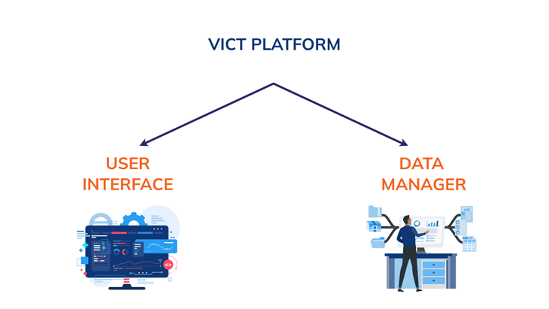
- Data Manager

2.1 User Interface
The user interface comprises of the following modules:-
- Home
- Decision Tool
- Explore technologies
- About
- Resource Center
- Publication
- Guidelines and Tools
- Videos
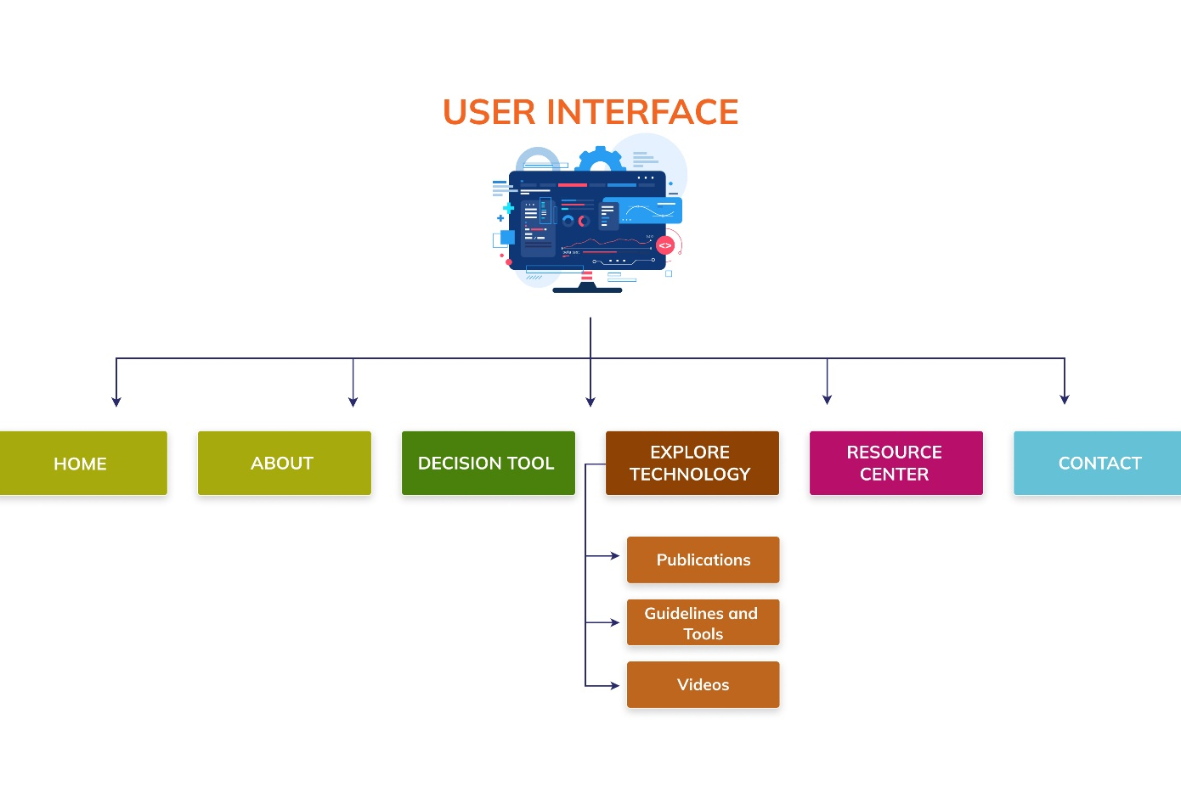
- Contact

2.2 Admin Panel
This is a web application with restricted access. Users with valid credentials can log in to access the application. The first user is a super admin, pre-created in the system. The super admin manages and creates other users within the application. The following are the modules of this application:
- Data Summary
- Data
  - Data Entry
  - Data Approve
  - Driver Data Entry
  - Indicator Metadata
  - Import Data
  - Import Log
  - Download Data
- Content
  - Category - Subcategory
  - Documents
- Admin
  - Area
  - Time Period
  - Data Source
  - Indicator
  - Import Mapping
  - Classification
- Classification Type
- Classification
  - User
  - Language
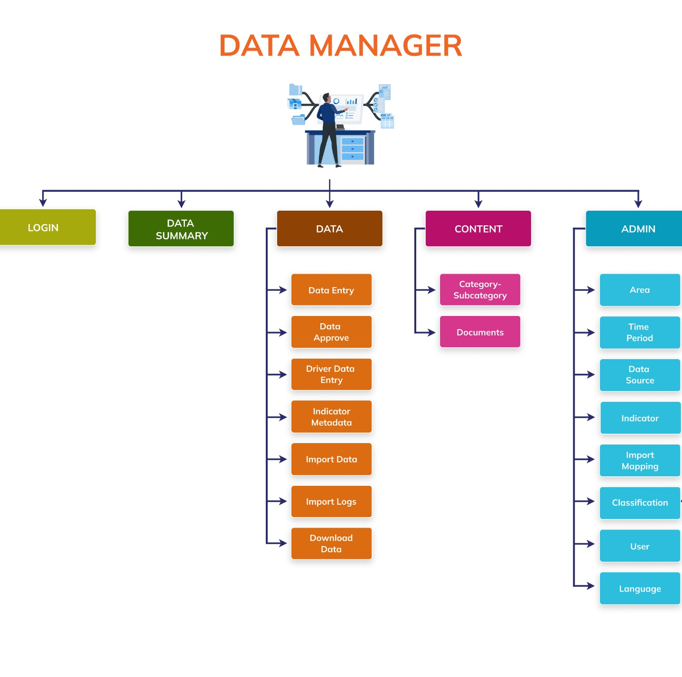

3.0 TECHNOLOGY STACK
The platform is developed using the following open-source technology and tools.
Component | Technology
Operating System | Ubuntu (RHEL) v 20.04
Front-end Language | HTML v5.0, CSS v3.0, JavaScript ES2022
Visualization Library | Leaflet v1.9.3
Front-end Framework | Angular v16
Back-end Language | Node.js v18, PHP v7.4
Back-end Framework | Express v4.16.2, Laravel v8.11.2
Database System | MongoDB v5.0
Server Type | Apache v2.4*, Docker v20.10.7, Docker composer v1.27.0

4.0 HOSTING
The data manager and the API gateway for the User Interface is hosted in the cloud-based servers and is accessible via web browsers on desktop and mobile devices. It is compatible with major browsers such as Chrome, Firefox, Safari, and Edge.
Hardware Interfaces
The platform is deployed on web servers. Internet or LAN connections is required for the users to connect to the server.
Software Interfaces
The platform is developed using open-source technologies that would allow easy extensibility and scalable communication interfaces. The platform uses the HTTP protocol for communication over the internet.
It will need an internet connection to be deployed on the web servers which are termed as Virtual Machine (VM). Below are the suggested VM specifications:
Processor 8 vCPU
Memory 16 GB
Storage 500 GB SSD
Internet Connection 100 Mbps recommended
Ports 80, 27017, 6379, 443, 21, 22
Web servers shall be protected by the firewall. A public IP and dedicated domain will be needed. A web master shall be assigned the task of managing, troubleshooting and maintaining the web server. There shall be adequate uptime of the web server. A decent internet connection will be required for the web server to manage the expected network traffic.
Note: The above specifications are recommended requirements, though the platform will be able to be deployed on lower specification web-based instances with options of elastic storage and processor. Port 80 would be required only during the development process.

5.0 SYSTEM FEATURES

5.1 User Interface
Below are the features of each module of the user interface application:

5.1.1 Home
Description
The home page features branding, navigation, an interactive world map, categorized resources, and a footer with menus and social media links.
Features
The home page consists of five sections. The first section includes branding, logo, sliders, and a header menu for easy navigation. The second section contains a "Know More" button that redirects to the "About VICT" page. The third section includes an interactive world map, where users can click on highlighted regions to explore technologies or data. There is a map toolbar with zoom, reset, label toggle, download, and north symbol options. The fourth section showcases resources in three categories, each with a "View All" option. The footer contains navigation menus and links to the platform’s social media pages.

5.1.2 About
Description
The About module provides an overview of VICT, its objectives, and its data-driven approach to climate-resilient irrigation for vegetable production.
Features
The About module provides a brief overview of the VICT platform. It explains the platform's objectives, which focus on supporting climate-resilient irrigation practices for vegetable production. The module also outlines the technical approach used by VICT, highlighting the data-driven and evidence-based strategies that guide irrigation investments and climate adaptation efforts. This section gives users a clear understanding of the platform's purpose and the methods it employs to achieve its goals.

5.1.3 Decision Tool
Description
The Decision Tool module provides a structured, nine-step framework for planning and implementing IVP interventions in emergency settings.
Features
The Decision Tool module provides a structured framework for implementing Irrigation and Vegetable Production (IVP) interventions in emergency settings. It guides users through a nine-step decision-making process, with each step featuring targeted questionnaires to gather relevant information. Responses are assigned scores to help assess and prioritize actions. To begin, users select the Decision Tool option from the main menu and click the Start button. A pop-up with terms and conditions appears, requiring users to either accept or decline before proceeding. This module ensures a systematic approach to planning and executing IVP interventions.

5.1.4 Explore Technologies
Description
The Explore Technologies module enables users to analyze irrigation technologies using interactive map of the selected area and downloadable data for informed decision-making.
Features
The Explore Technologies module allows users to analyze irrigation technologies based on various factors. Upon selecting this module from the main menu, a pop-up window appears with a welcome message and usage instructions, along with an option to disable future pop-ups. After clicking Proceed, a step-by-step guide walks users through the selection process. Users choose variables such as geographical area, season, crop water requirements, water source, depth/distance, and irrigation technology to generate a thematic map. By default, the system displays Sustainability data, but users can switch to the Drivers view. A legend on the left side helps interpret data, while a toolbar allows zooming, resetting, toggling labels, and downloading data in CSV format. The module also provides a data source and disclaimer for reference.

5.1.5 Resource Center
Description
The Resource Center module provides categorized access to publications, guidelines, tools, and videos related to vegetable irrigation and climate resilience.

5.1.5.1 Publications
Description
This sub-module provides categorized access to VICT-related publications with options to read more, download, search, and filter by year.
Features
The Publications sub-module provides categorized resources related to the VICT platform. Categories are listed on the left, while corresponding publications appear on the right with brief descriptions and options to Read More or Download attachments if available. Users can search for specific publications or filter results by year to refine their selection.

5.1.5.2 Guidelines and Tools
Description
This section offers best practices, technical guidelines, and tools for vegetable irrigation and climate resilience, with search and filter options.
Features
The Guideline and Tools sub-module offers best practices, technical guidelines, and tools related to vegetable irrigation and climate resilience. Each resource includes a title, date, brief description, and a Read More option. Users can search for specific guidelines or tools and apply year-based filters for a more targeted search.

5.1.5.3 Videos
Description
This sub-module features VICT-related video resources with options to watch in full screen, read more, search, and filter by year.
Features
The Videos sub-module provides a collection of video resources related to the VICT platform. Each video entry includes a title, date, and brief description, along with options to Watch in Full Screen or Read More for additional information. Users can also search for specific videos and filter results by year.

5.1.6 Contact
Description
The Contact module provides CGIAR's regional office details and a query form for users to submit inquiries.
Features
The Contact module provides users with the contact details of the regional office of the CGIAR System Organization, including phone numbers, email addresses, and office location. Additionally, it features a query form where users can submit inquiries. To use the form, users must enter their Name, Email, Organization Name, and Enquiry Message, then click the Send button to submit their query. This module ensures easy communication with the organization for any assistance or information requests.

5.2 Admin Panel
Below are the features of each module of the data manager application:

5.2.1 Login
Description
The Login module allows users to securely access the web application with valid credentials
Features
Users can log in using their email and password, and authentication ensures only authorized access to the platform. Users must enter their email and password for authentication. The first user to register is a super admin, pre-created in the system.

5.2.2 Data summary
Description
The Data Summary module provides an overview of key database information immediately after login and can be accessed through the left panel menu.
Features
Users can view four main information boxes showing counts and update timestamps. Users can see the total count of indicators with the last update timestamp. Users can view the total count of areas with the most recent update time. Users can check the total count of sources with the last entry/update time. Users can view the total count of data values entered against unique combinations of Indicator-Unit-Subgroup, Area, Time Period and Source, along with the last update timestamp. Users can navigate to respective modules using arrow buttons provided in each information box.

5.2.3 Data
Description
The Data module can be accessed from the left panel menu and contains multiple submodules for managing various aspects of data in the system.
Features
Users can access seven submodules including Data Entry, Data Approve, Driver Data Entry, Indicator Metadata, Import Data, Import Log, and Download Data. Users can navigate between these submodules through the left panel menu options.

5.2.3.1 Data Entry
Description
The Data Entry sub-module allows users to manage the Data master list and can be accessed from the Data menu option in the left panel.
Features
Users can approve pending data records that have been added or updated through the Data Entry module. Users can approve individual pending records using the Approve option in the action column. Users can disapprove pending records with the Disapprove option and add remarks when confirming. Users can approve all data records at once using the Approve All button at the top left corner of the page. Users can see approved records move to the approved list for display in the user interface application.

5.2.3.2 Data Approve
Description
The Data Approve module allows users to manage approval of added/updated data records and can be accessed from the Data menu option in the left panel.

Features
Users can approve pending data records that have been added or updated through the Data Entry module. Users can approve individual pending records using the Approve option in the action column. Users can disapprove pending records with the Disapprove option and add remarks when confirming. Users can approve all data records at once using the Approve All button at the top left corner of the page. Users can see approved records move to the approved list for display in the user interface application.

5.2.2.3 Driver Data Entry
Description
The Driver Data Entry module allows users to manage the driver master list and can be accessed from the Data menu option in the left panel.
Features
Users can add a new driver record by clicking the Plus button at the top right corner. The following details must be entered: Area, Indicator/Unit/Season, Rank, and Map Image (marked in blue as mandatory fields). After entering the details, users can click the Add button to save the new record, which will then be visible in the list. Users can edit existing driver records by selecting the Edit option from the action dropdown. After making the necessary changes, users can click the Update button to save the edits. To delete a driver record, users can click the Delete option in the action dropdown. A confirmation popup will appear, and users need to confirm the deletion by clicking Yes.

5.2.2.4 Indicator Metadata
Description
The Indicator Metadata module allows users to manage the master data of indicators' metadata and can be accessed from the Data menu option in the left panel.

Features
Users can import data by clicking the Import button, which allows them to upload a data master list into the database. To do this, users must first enter the data structure in the template, browse for the file, and click the Upload button to begin the import process. The system will skip records containing blank entries, special characters, or duplicates. After the import, a Last Upload summary will display the count of successfully imported records, while an error log can be accessed from the Import Log module for any unsuccessful imports.
To add a new indicator metadata record, users can click the Plus button at the top right corner. Mandatory fields include selecting Indicator/Unit/Season, and entering at least one metadata. After entering the required details, users can click the Add button to save and confirm the new record. Users can edit existing records by selecting the Edit option from the action dropdown and updating the necessary details before clicking the Update button to save the changes. The Enable/Disable option in the action dropdown allows users to show or hide a specific indicator, with hidden indicators not being displayed in the list of indicators throughout the application. Finally, users can delete records by selecting the Delete option from the action dropdown, confirming the deletion when pop-up comes.

5.2.2.5 Import Data
Description
The Import Data module allows users to manage bulk data entry processes and can be accessed from the Data menu option in the left panel.
Features
Users can view the list of existing elements of the selected module, sort the list, search for specific records, download logs, and delete existing elements. Users can select the required module from the dropdown at the top left corner of the page. To import a new bulk data file, users can click the Plus button at the top right corner, which opens the Data Entry Import popup. In this window, users must select the relevant mapping, browse for the data file, and click the Upload button to start the import process. Users can download the log file by selecting the Log Download option from the action dropdown. To delete an element, users can select the Delete option from the action dropdown and confirm the deletion when prompted.

5.2.2.6 Import Log
Description
The Import Log module allows users to manage import logs and can be accessed from the Data menu option in the left panel.
Features
Users can view the list of existing logs, download and view log reports, and delete selected logs. A log is generated whenever a data template is imported into the database. Each log entry includes the file name, a summary of the import process (count of records imported, updated, or errored), the total records available in the import file, and the date & time of the import. Users can download a log file in CSV format using the Download option in the action dropdown. To delete a log, users can select the Delete option from the action dropdown and confirm the deletion when prompted.

5.2.2.7 Download Data
Description
The Download Data module allows users to download master data from the database and can be accessed from the Data menu option in the left panel.
Features
Users can view the list of available modules, sort the list, search for specific modules, and download data in CSV format. Users can download an empty data template by selecting the Download Template option in the action dropdown. To download the master data of a selected module, users can select the Download Data option in the action dropdown, which exports the data in CSV format.

5.2.4 Content
Description
The Content module manages all content master data and includes the following sub-modules: Category - Subcategory and Documents.
Features
It can be accessed through the Content button on the left menu. This module is divided into sub-modules that enable the creation and management of documents, content and category subcategory.

5.2.4.1 Category - Subcategory
Description
This sub-module allows the super admin to manage categories and subcategories within the system.
Features
The Category Subcategory module displays a list of existing categories and subcategories. Users can sort and search within the list to find specific entries. To add a new category-subcategory record, click the Plus button at the top right. The system requires selecting a Category Name and Subcategory Name before saving the record. Once added, the record appears in the list. The Action dropdown provides options to edit, delete, or enable/disable a category. Deleting a record prompts a confirmation popup to ensure intentional removal.

5.2.4.2 Documents
Description
This sub-module enables the super admin to manage documents, including publications, videos, and related materials.
Features
The Documents module displays a list of all existing documents, allowing users to sort and search as needed. To add a new document, click the Plus button at the top right, which opens a form requiring details such as Group, Title, Description, Document Date, and Tags. Additional fields appear depending on the selected group. If the group is Videos, the system requires a Video URL. If the group is Publications, it requires a Document Type, along with an uploaded document and image. The Action dropdown allows editing, deleting, and enabling/disabling documents. A confirmation popup appears when attempting to delete a document to prevent accidental removals.

5.2.5 Admin
Description
The Admin module will manage all the master data. It will have the following sub modules –Area, Time Period, Data Source, Indicator, Import Mapping, Classification, User and Language
Features
It can be accessed through the Admin button on the left menu. This module is divided into sub-modules that enable the creation and management of admin users and handling of data.

5.2.5.1 Area
Description
The Area Master sub-module enables the super admin to efficiently manage the area master list within the application. It provides a centralized system to add, view, edit, and manage areas, ensuring that only relevant areas are visible to users.

Features:
Admins can import area templates, which involve preparing the structure in a template, browsing for the file, and uploading it. The import process skips records with blank fields, special characters, or duplicates, and provides a summary of the successful imports along with an error log. Additionally, areas can be added manually by clicking the Plus button, entering the required details, and saving them. Admins can also edit or show/hide areas via the action column, allowing for quick updates to the list. Any changes made will be reflected immediately.

5.2.5.2 Time Period
Description
The Time Period sub-module allows the super admin to manage a list of time periods that can be applied across the application. This sub-module makes it easy to create, view, edit, and organize time periods.
Features
Admins can import and export time period templates, allowing for bulk updates to the list. To add a new time period, admins click the Plus button, enter the time period's name, and save the changes. Admins can also edit existing time periods or disable/enable them directly from the action column, ensuring flexibility in managing the list of time periods.

5.2.5.3 Data Source
Description
The Data Source sub-module is designed to help the super admin manage and configure data sources used in the system. It ensures that admins have control over what data sources are available to users.
Features
Admins can import and export data source templates for easy bulk operations. To add a new data source, admins simply click the Plus button, select the appropriate time period, and complete the required fields.

5.2.5.4 Indicator
Description
The Indicator sub-module allows the super admin to manage the indicator master list. This includes options for exporting and importing indicator templates, adding new indicator-unit-subgroup (IUS) combinations, and managing the list of existing indicators. The sub-module also provides functionality to sort, edit, and show or hide indicators.
Features
Admins can import indicator data by selecting a pre-prepared template and uploading it. During the import, records with blank entries, special characters, or duplicates are excluded, and a summary of the successful imports is provided. An error log is generated to report any unsuccessful imports. Each IUS must be classified under either Sector-Subsector or Goal-Target. Admins can view indicator details by clicking on the View option in the action column.

5.2.4.5 Import Mapping
Description
The Import Mapping sub-module helps manage the mapping master list, allowing admins to add new elements, view the list, sort, and search existing mappings. It also provides the ability to edit and delete elements.
Features
Admins can add new mappings by entering details such as Mapping Name, Area Column, Indicator, and Mapping Column. These details are mandatory for the creation of a new record. After adding, the new record is displayed in the list. Admins can also edit or delete records using the action dropdown, confirming each change via a popup.

5.2.4.6 Classification
Description
The Classification sub-module consists of two parts: Classification Type and Classification itself. It allows admins to manage the classification data and provides the ability to import, add, view, and modify classification records.

5.2.4.6.1 Classification Type
Description
The Classification Type sub-module allows admins to manage the master list of classification types. Admins can add new classification types, view the existing list, sort records, and perform edit
Features
To add a new classification type, admins must select the Classification Type and Global options and then save the record. They can also edit or delete existing classification types using the action dropdown. Deleting a classification type requires a confirmation popup.

5.2.4.6.2 Classification
Description
The Classification sub-module within the Classification module allows admins to manage classification metadata. It provides options for importing data templates, adding new entries, and editing or deleting existing records.
Features
Admins can import classification data by selecting a template and uploading it. Invalid records are excluded during the import process, and a summary is provided. New records can be added by entering the required details, and admins can edit, enable/disable, or delete existing records via the action dropdown.

5.2.4.7 User
Description
The User sub-module enables admins to manage the user master list. Admins can add new users, view existing users, search, edit, and manage user status (active/inactive).
Features
To add a new user, admins must enter mandatory details like User Name, Area, Indicators, Email, Phone Number, Role (e.g., Data Entry, Data Approver), and Password. New users are saved to the list upon confirmation. Admins can also edit user details or toggle their status between active and inactive. Inactive users will not be able to log in.

5.2.4.8 Language
Description
This sub-module allows the admin to manage language translations for portal strings in English, Dutch, French, and Spanish. It provides options to export and import translation templates, update existing translations, and manage language strings categorized under
- Indicator
- Unit / Season
- Subgroup
- Subgroup Dimension
- Metadata
- Classification Type
- Classification
- Category / Subcategory
- Document
- Source
Features
Click on the Language option from the Admin menu in the left panel to access this module Admins can export translation templates by selecting a category and clicking the Export button. The downloaded template contains French column. Users can choose to export an empty template or a template with existing data from the database. Admins can import translated strings by clicking the Import button, selecting the translation file, and clicking Upload. After a successful import, a summary displays the number of successfully imported records

---- End of the Document ----

